

Online Event Management

A Software Project Submitted

By

|  |  |
| --- | --- |
| Name | ID |
| **Hride, Shanjida Akter** | 17-33570-1 |
| **Chuity, Sanzida Mannan** | 17-33480-1 |
| **Kazi, Tariqul Islam** | 16-33019-3 |
| **Bondhon, Md Rafiul Hasan** | 17-34276-1 |

Under the supervision of

**Abhijit Bhowmik**

Senior Assistant professor & Special Assistant

Office of Student Affairs

Department of Computer Science

Faculty of Science and Information Technology

American International University Bangladesh

Summer Semester 2019-2020

**Disclaimer**

This is to certify that this project is our original work. No part of this has been submitted elsewhere partially or fully for the award of any other degree. Any material reproduced in this project has been properly acknowledged.



________________________________________

1. Name: Hride, Shanjida Akter

ID No: 17-33570-1



________________________________________

2. Name: Chuity, Sanzida Mannan

ID No: 17-33480-1



________________________________________

3. Name: Kazi, Tariqul Islam

ID No: 16-33019-3



________________________________________

4. Name: Bondhon, Md Rafiul Hasan

ID No: 17-34276-1

**Approval**

The Software Project or Project titled “Online Event Management” has been submitted to the following respected members of the Board of Examiners of the Faculty of Science and Information Technology in partial fulfillment of the requirements for the degree of Bachelor of Science in Software Engineering on 25th September 2020 by the following students and has been accepted satisfactory.

|  |  |
| --- | --- |
| ____________________________  **Abhijit Bhowmik**  Faculty & Supervisor  Department of Computer Science  American International University- Bangladesh | ____________________________  **MD. Sadrul Amin**  Faculty  Department of Computer Science  American International University- Bangladesh |
| ____________________________  **Dr. M M Mahbubul Syeed**  Head (Undergraduate)  Department of Computer Science  American International University- Bangladesh | ____________________________  **Professor Dr. Tafazzal Hossain**  Dean in Charge  Faculty of Science & Technology American International University-Bangladesh |
| ____________________________  **Dr. Carmen Z. Lamagna**  Vice Chancellor  American International University-Bangladesh | |

**Acknowledgements**

We would like to take the chance to express our gratitude to our honorable teacher & Supervisor Abhijit Bhowmik, for his continuous guidance and support regarding this report. Besides this, we have found so many sincere and productive advices from many people that we would like pay homage to them. We convey our gratitude to our honorable Vice Chancellor, Dr. Carmen Z. Lamagna for encouragement.

Table of Contents

CHAPTER 1: STATEMENT OF WORK 9

1.1 Purpose/Objectives 9

1.2 Scope 9

1.3 Proposed System 10

1.4 System Features 11

1.5 Environment 12

Organizations Involved 12

Processing 12

Security 13

1.6 Assumptions 13

1.7 Constraints 13

1.8 Proposed System 15

1.8.1 Description/Improvements of Proposed System 15

1.8.2 Resources 15

1.8.3 Hardware 15

1.8.4 Software 15

1.8.5 Operating Environment 16

1.9 Project Time & Cost 16

1.9.1 Project Period 16

1.9.2 Project Schedule 16

1.9.3 Domain & Hosting Package 17

1.10 Risk assessment 20

1.11 Assessing overall project risk 21

CHAPTER 2: SOFTWARE REQUIREMENT SPECIFICATION 23

2.1 Objectives and Scope 23

2.2 Overview of the Present System 23

2.3 Data Flow Diagram of the Present System 23

2.4 Weakness of the Present System 23

2.5 Overview of the Proposed System 24

2.6 Benefits of Proposed System 24

2.7 System Features 25

2.8 Hardware and Software Requirements 26

2.8.1 Hardware 26

2.8.2 Software 27

2.9 Human Resource Requirements 27

2.10 Constraints and Limitations 27

2.11Budget 28

2.12 Conclusion 28

CHAPTER-3: DIAGRAM 29

3.1 Use Case Diagram 29

3.1.1. Admin Functionality: 29

3.1.2 VENDOR Functionality: 31

3.1.3 Unregistered User (Visitor): 32

3.1.4 Registered User (Customer): 32

3.2 Activity Diagram 33

3.2.1. Admin: 33

3.2.2 CUSTOMER: 34

3.2.3 VENDOR 35

3.3 ER DIAGRAM 36

3.4 Prototype 37

CHAPTER-4: SOFTWARE PROJECT MANAGEMENT PLAN 47

4.1 Document History and Distribution 47

4.1.1 Test Plan 47

4.1.2 Revision History 60

Shanjida Hride 60

4.2 Overview 60

4.2.1 Purpose, Objectives and Project Scope 60

4.2.2 Project Scope 61

4.2.3 Assumptions and Constraints 61

4.3 Project Deliverables 61

4.3.1 The list of project deliverables is: 61

4.3.2 Schedule and Budget Summary 61

4.4 Evolution of the Software Project Management Plan 62

4.4.1 Definitions 62

4.5 Project Organization 62

4.5.1 External Interfaces 63

4.5.2 Internal Structure 63

4.5.3 Roles and Responsibilities 63

4.6 Managerial Process Plans 63

4.6.1 Project Start-up Plan 63

4.6.2 Estimation Plan 63

4.6.3 Staffing Plan 64

4.6.4 Resource Acquisition Plan 64

4.6.5 Project Staff Training Plan 64

4.7 Work Plan 64

4.7.1 Budget Allocation 64

4.8 Control Plan 65

4.8.1 Requirements Control Plan 65

4.8.2 Schedule Control Plan 65

4.8.3 Budget Control Plan 65

4.8.4 Quality Control Plan 67

4.8.5 Reporting Plan 67

4.8.6 Metrics Collection Plan 67

4.9 Risk Management plan 68

4.10 Closeout Plan 68

4.11 Technical process plans 68

4.12 Process Model 69

4.13 Methods, Tools and Techniques 69

4.14 Infrastructure Plan 69

4.15 Product Acceptance Plan 69

4.16 Supporting Process Plans 69

4.17 Configuration Management Plan 70

4.18 Verification and Validation Plan 70

4.19 Documentation Plan 70

4.20 Quality Assurance Plan 70

4.21 Reviews and Audits Plan 71

4.22 Problem Resolution Plan 71

4.23 Subcontractor Management Plans 71

4.24 Process Improvement Plan 71

REFERENCES: 72

# CHAPTER 1: STATEMENT OF WORK

## 1.1 Purpose/Objectives

The main purpose of this proposal is to reduce the hassle to find the appropriate event management and make sure proper good service for all. This app will show the event management info like package, price, timing, place, particle, and availability schedule which will help users to find the event management they need with ease.

The feasibility study will provide fundamental investigations into the potential benefits associated with this project. The main purpose of the feasibility study is to cover all issues associated with the project and determine if the investment of time and other resources will lead to a desirable result.

One of the most important aspects of the study is to ensure that the total investment needed to successfully bring the project to completion is considered. Often, this will include addressing components such as cash reserves, labor, construction, production facilities, outsourcing, and the cost of raw materials. Only when the feasibility study has addressed the total cost of completing the project can the study progress to the next level.

As a second major component, the feasibility study will also address costs and other factors that are indirectly associated with the project.

The utilization of a feasibility study has often assisted companies in understanding which projects to develop and which ones to abandon before investing resources in something that ultimately shows no promise of generating revenue. Taking the time to engage in a pilot or feasibility study does involve some usage of available resources, but these costs are much more readily absorbed than the larger amount that would be expended on a project that ultimately proved to be worthless.

## 1.2 Scope

The scope of the project is much specified as it outlines the modern Online Event Management System to be incorporated in individual business models. Our system is divided into Four phases those are:

* Providing an efficient package, price, timing, place, particle
* Customization and improvement of existing system.
* Individual information module for each event package, place, interesting things to do etc
* Individual information module for each client.

This is an online event management system software project that will serve the functionality of an event manager. The project will provide most of the basic functionality required for an event. It will allow the user to select from a list of event types. Once the user enters an event type (Marriage, Birthday, etc.), the system will display some packages to choose for the event. As many service providers will be connected with the system, clients can be able to find their expected organizer/service provider with complete details for their event. It will allow the user to select the date and time of the event.

## 1.3 Proposed System

our software or Web Application is intended for implementing an **Online Event Management** system so that a customer can easily access to our service from anywhere, anytime. The project will provide most of the basic functionality required for an event. It will allow the user to select from a list of event types. Once the user enters an event type (Marriage, Birthday, etc), the system will display some packages to choose for the event.

Benefits or Improvements of Proposed System

* Client satisfaction
* Choices from the best package
* No hassle for organize
* Information of all kind of event service that can be accessed on demand.
* Client can customize various service
* Varieties of payment options
* Instant transaction history
* Customize based on the client’s preferences and budgets
* Well planned budget for event
* Client can give review

## 1.4 System Features

**Admin**

Admin has the highest authority over the entire system. Admin responsibilities consists of update or modify existing system, ensure data security and user authentication, assign necessary role and privileges system users and as well as to the clients. Admin has the power to take away provided privileges that has been assigned to users or clients.

* Manage vendor
* Create Event package & price
* Update and Delete related operations
* Update role & policy
* create content details
* See complaint & feedback reports
* Approve “cancel Event & cash back” request

**Unregister User**

* See/search contents (Service & package, price, timing, place, particle, review)
* Check availability of Event date & pricing
* Recommend products according to their recent search.

**Register User**

* See/search contents
* Check availability of Event date, pricing & Place
* Make/customize event Schedule
* event packages booked
* report a problem
* get notification about new updates and bookings
* Can request for order Cancel
* Give review & ratings
* can send emails or messages

**vendor**

* adds package
* Update Package
* Give discount & offer with time schedule.
* Delete package
* delete package pricing.

**Customer and Vendor Admin Panel User Profile**

* See and update personal information
* Change password
* Customization according to choose
* Registered client’s account information and transaction history.

**Booking**

* Viewing available service and package
* Different type of offers (optional)

**Payment**

* Many types of payment systems
* Keep logs of all transaction history
* Security and authentication verification

**Transaction Security**

* Login/Registration/Authentication and Validation process

## 1.5 Environment

### Organizations Involved

Project Client: ABHIJIT BHOWMIK

Developer: Online Event Management

User: Random users or customers or Vendor

### Processing

* This Web Application will have a graphical user interface which will be able to view by any browser
* That means it’s a website or web application which is browser independent.
* Three working modules. Administrator and Customer and Vendor
* This website will store the information of all registered user which can be viewed by themselves and the administrator of this software.
* Authenticated and secure login system and secure data transmission for all users.
* Detailed log of all purchase and sell history.

### Security

System’s security requirements:

* User authentication is required to access the application.
* A client or user must be a registered user to login to use the features.
* Without proper authentication no transaction will be allowed.
* The details of the user must be safe and secure

## 1.6 Assumptions

Some third-party software may be used to build up this project. These are free components, most of them are open source. We have used Opera, Mozilla Firefox, and Google Chrome etc. as a web browser to access user interface as client application. So, our project will not be affected because we are not using anything for which it becomes illegal to use.

Some open source libraries and software’s are used to build up this project:

* PHP ZIP files Library to use file compression.
* PHP Session to verify user login,
* For dynamic interface some Ajax library is used.
* MOO tools, JQuery

## 1.7 Constraints

1. Usage outside regulation: Data passes from client to server through TCP/IP & we are not using any public key encryption service like SSL certificate. So we have constraints in case of passing user data. It may cause – Confidentiality, Integrity problems. Only registered users are valid & valid users can use the software through Client Application with help of Internet Browser on server side. For any missing password found by anonymous user, responsibility goes to valid user.
2. Bandwidth limitations: It may lose server connection for technical error (Depends on Hardware/Internet connection). We need to run query again.
3. Databases: Databases we are using MySQL Database. User queries more than server’s limitations we need to check databases and refresh table data. In case of lack of DB caching.
4. Parallel operations: Parallel use of other Internet application with this software may hamper in bandwidth, may occur taking time for a query for slow connections
5. Language requirements: Language is used in this software is PHP. Suppose any user wants Oracle Database we need to use bind variable technique.
6. Communications protocols: Communication protocols we are using- TCP/IP to interact with the server. Other protocol is not considerable if user wants.
7. Security considerations: If user doesn’t want to buy SSL security then client applications will not be using any public key encryption service like SSL certificate (i.e. 128-bit RSA encryption). So, we have constraints in case of passing user data.

It may cause (In case of internet security) –

1. **Authentication problem:** Server may not recognize/confirm actual valid user.
2. **Confidentiality problem:** User, intended server fails “understanding” message contents.
3. **Integrity problem:** sender, server may fail to ensure message not altered without detection
4. **Eavesdrop**: There may be Intercept messaging, actively insert messages into connection
5. **Impersonation:** can fake (spoof) source address in packet (or any field in packet)
6. **Hijacking:** “take over” ongoing connection by removing sender or server, inserting himself in place
7. **Denial of service:** prevent service from being used by others (e.g., by overloading resources)

## 1.8 Proposed System

### Description/Improvements of Proposed System

* Client’s satisfaction
* Reduce the erroneous data entry
* Efficient, smooth and easy transaction
* Fast management/transaction.
* Monitor system performance efficiently (Depends on various factors)
* Reduce system loading time

### Resources

All the resource needed is provided below.

### Hardware

Minimum requirements for server:

* Processor: Xeon based microprocessor.
* RAM: 16 GB.
* System Type: Linux (64 bit).
* Storage: 256 GB SSD.
* For Storage Service: Network File System (NFS)

Minimum requirements for client:

* Processor: Dual-core.
* RAM: 2 GB.
* System: Windows, MAC OS X, Linux.
* Web Browser: Firefox, Google Chrome, Opera

### Software

* Notepad++ / Sublime Text.
* PHP, MySQL.
* Apache

### Operating Environment

The system will be operated from the external (your preferred data center) Linux Server in which site will be hosted. Hosting server has 99% Uptime. This website is platform independent. User application is accessible through various kinds of browsers like Opera, Mozilla Firefox, and Google Chrome etc. This website is a web application where client application has user interfaces through browser and main part is hosted on Apache Server. IBM or MAC any platform user can use. Operating System can be used Windows of any version from Windows 98, Windows XP/Vista to Windows 10, MAC OS X 10.5 or above.

## 1.9 Project Time & Cost

### Project Period

* Expected time of completion of project is 4 months.

### Project Schedule

|  |  |
| --- | --- |
| **Term** | **Description** |
| **BA** | **Business Analyst** |
| **PM** | **Project Manager** |
| **D** | **Developer** |
| **QT** | **Quality Tester** |

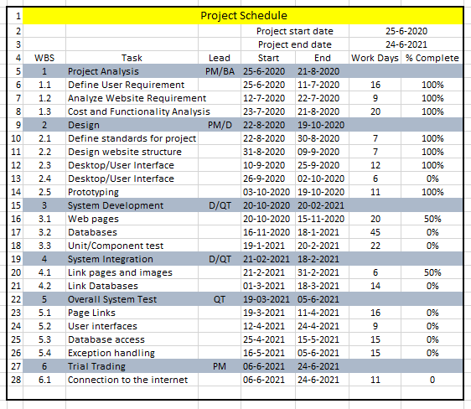

### Domain & Hosting Package

**Domain**

* **.com** ৳ 1000/year
* **.net** ৳ 950/year
* **.org** ৳ 950/year
* **.biz** ৳ 1000/year
* **.info** ৳ 900/year

**Hosting Package A:** Great for small websites

* Web Space: 1GB SSD Storage
* Bandwidth: 30GB/monthly
* RAID 10 SSD Server
* Unlimited Sub Domains
* Unlimited Email Accounts
* Unlimited Databases
* Tk. 1500/Year

**Hosting Package B:** Perfect for medium sized websites

* 3GB SSD Storage
* 90 GB Bandwidth Monthly
* RAID 10 SSD Server
* LiteSpeed Web Server
* Three Addon Domains
* Unlimited Sub Domains
* Unlimited Email Accounts
* Unlimited Databases
* Tk. 2500/year

**Hosting Package C:** For the demanding sites

* 5 GB SSD Storage
* 150 GB Bandwidth Monthly
* RAID 10 SSD Server
* LiteSpeed Web Server
* Five Addon Domains
* Unlimited Sub Domains
* Unlimited Email Accounts
* Unlimited Databases
* Tk. 3500/year

**Hosting Package D:** For the highly demanding sites

* 20 GB SSD Storage
* 500 GB Bandwidth Monthly
* RAID 10 SSD Server
* LiteSpeed Web Server
* Nine Addon Domains
* Unlimited Sub Domains
* Unlimited Email Accounts
* Unlimited Databases
* Tk. 7000/year

Estimated service cost

|  |  |
| --- | --- |
| **Description** | **Cost Assumption** |
| Site launch (hosting) | 30,000 BDT |
| Maintenance (1 year) | 80,000 BDT |
| Developers | 2,00,000 BDT |
| **Grand total** | **3,10,000 BDT** |

## 1.10 Risk assessment

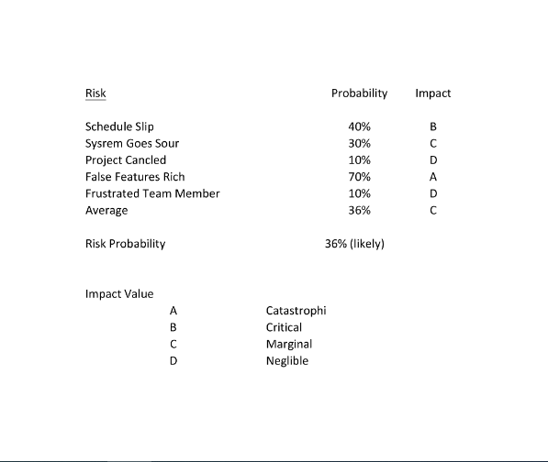

The impact of each risk driver on the risk component is divided into one of four impact categories—negligible, marginal, critical, or catastrophic

|  |  |  |  |  |
| --- | --- | --- | --- | --- |
|  | **Catastrophic** | **Critical** | **Marginal** | **Negligible** |
| **Schedule slip** |  | Project delay, exceed budget |  |  |
| **System goes sour** |  |  | Grading miscalculation, Unauthorized access |  |
| **Project canceled** |  |  |  | Booking cancelation |
| **False features rich** | System doesn’t give proper output.  Unable to fulfill requirement |  |  |  |
| **Frustrated team members** |  |  |  | Fail to meet deadline |

## 1.11 Assessing overall project risk

1. Have software engineer team formally committed to support the project?

Answer: Yes. All the members are formally committed to support the project. They also ensure that they will give all types of available facilities.

2. Are requirements fully understood by the software engineering team and their customers?

Answer: Yes. As the software engineering team or the developers has the sound knowledge about the requirements so it is easily understandable by the team. The requirements details are well organized also informative, so it is under stable by the customers.

3. Are end-users enthusiastically committed to the project and the system/product to be built?

Answer: Yes. Because the end-users are expecting that, they will be able to find all kind of information about Chain Store Management System.

4. Have user been involved fully in the definition of requirements?

Answer: Yes. The user has been fully involved in the definition of requirements. They are aware of the application requirements.

5. Is project scope stable?

Answer: Yes. Project scope is stable because the minimum and mandatory scope is almost covered by the software engineering team. If any further scope will arise then just adding it with the old ones.

6. Does the software engineering team have the right mix of skills?

Answer: Yes. The software engineering team has the right mix of skills. The team members have the capability of doing their work in a team, ability to work in pressure and also have sound knowledge according to the software implementation.

7. Are project requirements stable?

Answer: Yes. Currently all possible requirements are being listed, and seem that if anything would be added later to the list will not make the project unstable. All requirements for this project are easily available that will enthusiast the end-user to use it.

8. Does the project team have experience with the technology to be implemented?

Answer: Yes. The project team has experience with the technology to be implemented because they have the sound knowledge about the technologies and the technologies are also implemented by them before.

9. Does the project team and client are aware about the possible risks?

Answer: Yes. Project team prepare the possible risk assessment and aware of handling the risk. Client is also being notified

# CHAPTER 2: SOFTWARE REQUIREMENT SPECIFICATION

## Objectives and Scope

The scope of the project is to ease the people Online Event Management. The system

provides a hassle-free experience to the user where they can book their event.

Besides, this system is built in such a way that anyone can be a merchant just by

opening a merchant account.

The Online Event management software is supposed to have the following features:

* A user can be a customer as well as a vendor.
* Vendor can see their statement.
* System provides the users promotional discount for inviting time
* The system lets the administrator who has the highest authority manage the vendor and the user and the content of the system.
* User can give ratings to the product.
* The features described here meet the needs of all the users.

## Overview of the Present System

Currently there are very few systems like BDshowbiz, Dhaka Event Planner etc implemented in

Bangladesh that are offering the same thing like us but there are some features which distinguish our system than others.

## Data Flow Diagram of the Present System

* Not required.

## Weakness of the Present System

* Less information
* Most of the information are not updated.
* No profiles for patients.
* Restriction on payment method.
* many lacking and issues do exist while planning an even

## Overview of the Proposed System

Our proposed system, this is an online event management system software project that will serve the functionality of an event manager. The system will allow registered users to log in and new users are allowed to register on the application. The project will provide most of the basic functionality required for an event. It will allow the user to select from a list of event types. Once the user enters an event type (Marriage, Birthday, etc), the system will display some packages to choose for the event. As many service providers will be connected with the system, clients can be able to find their expected organizer/service provider with complete details for their event. It will allow the user to select the date and time of the event. All this data is logged in the database and the user is given a receipt number for his booking. This data is then sent to the event managers team and they may interact with the manager via inbox conversation/email and contact data stored in the database.

## Benefits of Proposed System

**Benefits /Improvements of Proposed System**

* Client satisfaction
* Choices from the best package
* No hassle for organize
* Information of all kind of event service that can be accessed on demand.
* Client can customize various service
* Varieties of payment options
* Instant transaction history
* Customize based on the client’s preferences and budgets
* Well planned budget for event
* Client can give review
* When client search event type auto-suggestion helps him to find it
* Improved client interactions.
* Users can invite their friends into the system

## System Features

**Admin**

An admin can do all CRUD operations and access or handle the entire system as well as do all administrative works.

* Create vendor
* Create Event package & price
* Update and Delete related operations
* Update role & policy
* create content details
* See complaint & feedback reports
* Approve “cancel Event & cash back” request

**Unregister User**

* See/search contents (Service & package, price, timing, place, particle, review)
* Check availability of Event date & pricing
* Recommend products according to their recent search.

**Register User**

* See/search contents
* Check availability of Event date, pricing & Place
* Make/customize event Schedule
* event packages booked
* report a problem
* get notification about new updates and bookings
* Can request for order Cancel
* Give review & ratings
* can send emails or messages

**vendor**

* adds package
* Update Package
* Give discount & offer with time schedule.
* Delete package
* delete package pricing.

**Customer and Vendor Admin Panel User Profile**

* See and update personal information
* Change password
* Customization according to choose
* Registered client’s account information and transaction history.

**Booking**

* Viewing available service and package
* Different type of offers (optional)

**Payment**

* Many types of payment systems
* Keep logs of all transaction history
* Security and authentication verification

**Transaction Security**

* Login/Registration/Authentication and Validation process

## Hardware and Software Requirements

### Hardware

Minimum requirements for server:

* Processor: Xeon based microprocessor.
* RAM: 16 GB.
* System Type: Linux (64 bit).
* Storage: 256 GB SSD.
* For Storage Service: Network File System (NFS)

Minimum requirements for client:

* Processor: Dual-core.
* RAM: 2 GB.
* System: Windows, MAC OS X, Linux.
* Web Browser: Firefox, Google Chrome, Opera

### Software

* Notepad++ / Sublime Text.
* PHP, MySQL.
* Apache

## Human Resource Requirements

The total human resource needed for implementing and operating the system is mentioned below.

* Hardware Specialist: A part time hardware specialist is needed to manage all the computers of the center. So, in case of any hardware failure he/she may come and solve the problem.
* Computer operator/Data entry operator: A computer operator is needed to upload the online question to the system in case specific user lacks the systems know how.

## Constraints and Limitations

Assumptions and Dependencies

* The users have sufficient knowledge of computers.
* The user’s computer should have Internet connection and Internet server capabilities.
* The users know the English language, as the user interface will be provided in English. Constraints
* Bandwidth limitations: It may lose server connection for technical error (Depends on Hardware/Internet connection). We need to run query again.
* Databases: Databases we are using Oracle Database. User queries more than server’s limitations we need to check databases and refresh table data.
* Parallel operations: Parallel use of other Internet application with this software may hamper in bandwidth, may occur taking time for a query for slow connections.
* Language requirements: If any user wants to use any language other that what we used for Oracle Database; we need to use bind variable technique.
* Communications protocols: Communication protocols we are using- TCP/IP to interact with the server. Other protocol is not considerable, if user wants.

## 2.11Budget

|  |  |
| --- | --- |
| **Description** | **Cost Assumption** |
| Site launch (hosting) | 30,000 BDT |
| Maintenance (1 year) | 80,000 BDT |
| Developers | 2,00,000 BDT |
| **Grand total** | **3,10,000 BDT** |

## 2.12 Conclusion

This Requirement Specification Document has been developed based upon by the studying common scenario and previous experience of the project manager. Thus, any unusual circumstances rise on the process of development may derail the values and time frame mention in this document

# CHAPTER-3: DIAGRAM

## 3.1 Use Case Diagram

### 3.1.1. Admin Functionality:

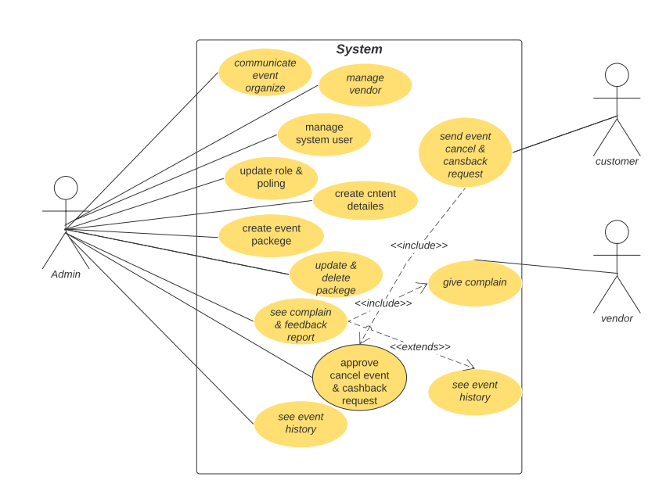

**Admin**

Admin has the highest authority over the entire system. Admin responsibilities consists of update or modify existing system, ensure data security and user authentication, assign necessary role and privileges system users and as well as to the clients. Admin has the power to take away provided privileges that has been assigned to users or clients.

* Manage vendor
* Create Event package & price
* Update and Delete related operations
* Update role & policy
* create content details
* See complaint & feedback reports
* Approve “cancel Event & cash back” request
* See event history

### 3.1.2 VENDOR Functionality:

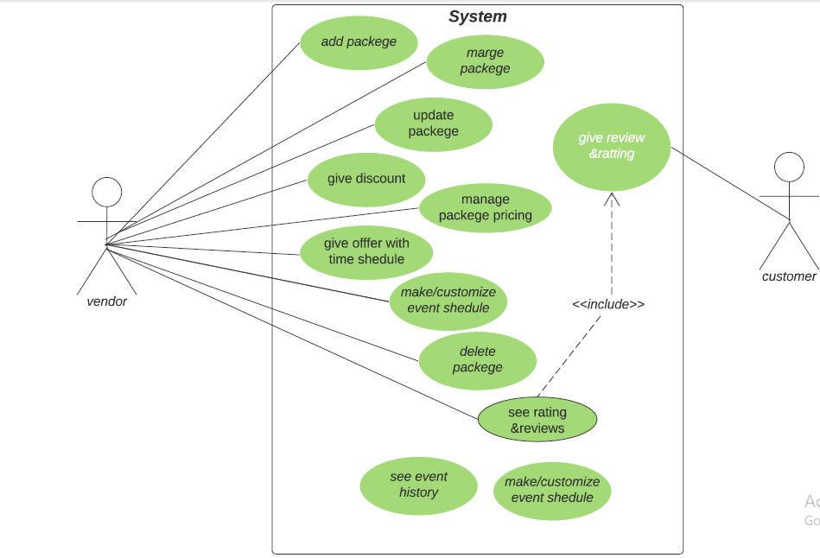

**Vendor**

* adds package
* Update Package
* Give discount & offer with time schedule.
* Delete package
* Delete package pricing
* Give discount & offer
* See event history

### 3.1.3 Unregistered User (Visitor):

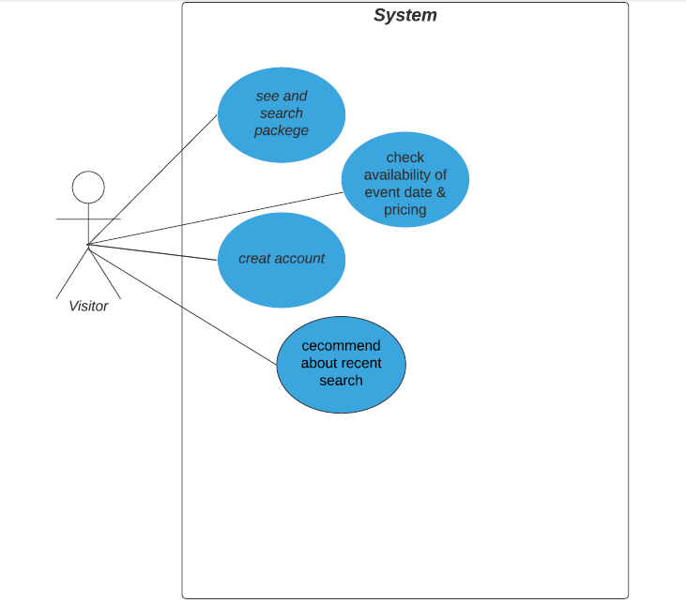

**Unregister User**

* See/search contents (Service & package, price, timing, place, particle, review)
* Check availability of Event date & pricing
* Recommend products according to their recent search.

### 3.1.4 Registered User (Customer):

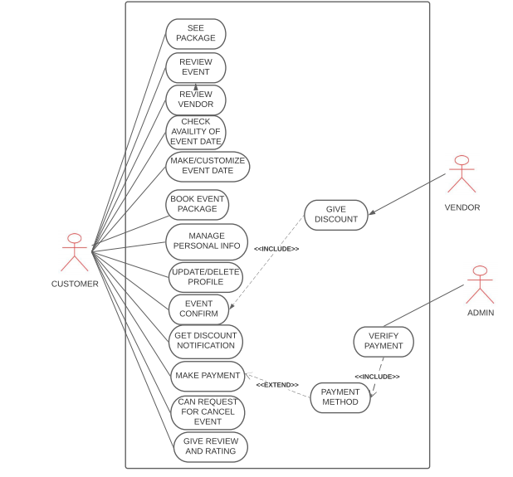

**Register User**

* See/search contents
* Check availability of Event date, pricing & Place
* Make/customize event Schedule
* event packages booked
* report a problem
* get notification about new updates and bookings
* Can request for order Cancel
* Give review & ratings
* can send emails or messages

## 3.2 Activity Diagram

### 3.2.1. Admin:

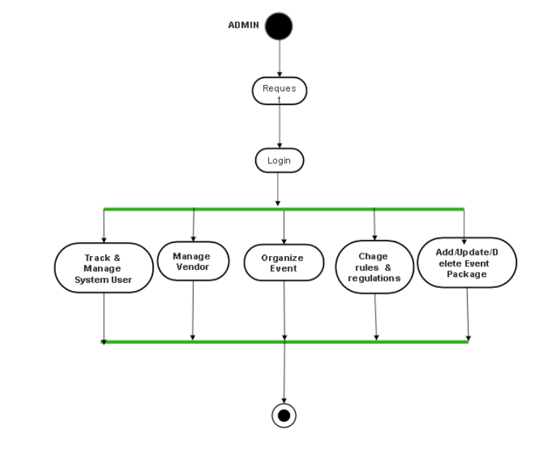

The above attached Admin Activity Diagram explains admin username and password

validation through requesting login web form, managing user orders, manage vendor

manage events , manage rules and regulations etc.

### 3.2.2 CUSTOMER:

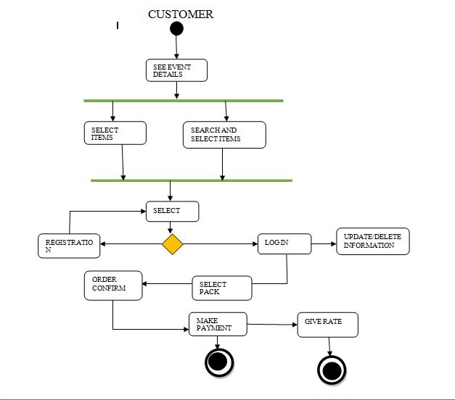

The above attached Customer Activity Diagram explains about user details, book

event, view event, manage information, payment, rating etc.

### 3.2.3 VENDOR

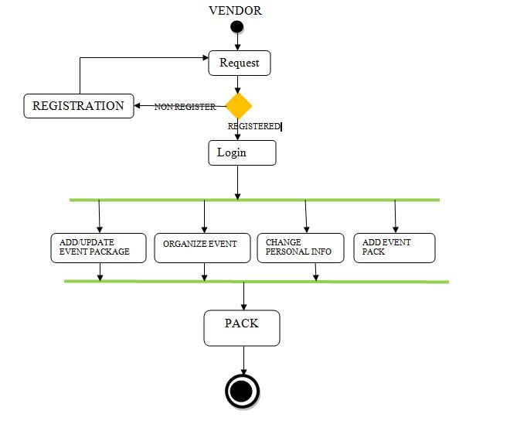

The above attached Vendor Activity Diagram for Online Event Management explains about

vendor package details, manage personal information, order list, rating etc

## 3.3 ER DIAGRAM

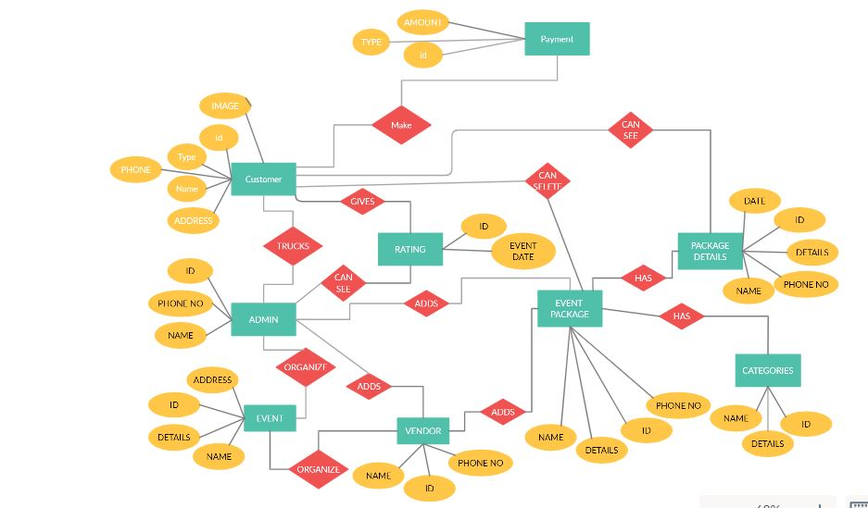

This ER (Entity Relationship) Diagram represents the model of Online Event Management Entity. The entity relationship diagram Online Event Management System shows all the visual instrument of Database tables and the relation between Vendor, Customer, Admin etc. It used Structure data and to define the relationships between structured data groups of Online Event Management functionalities.

## 3.4 Prototype

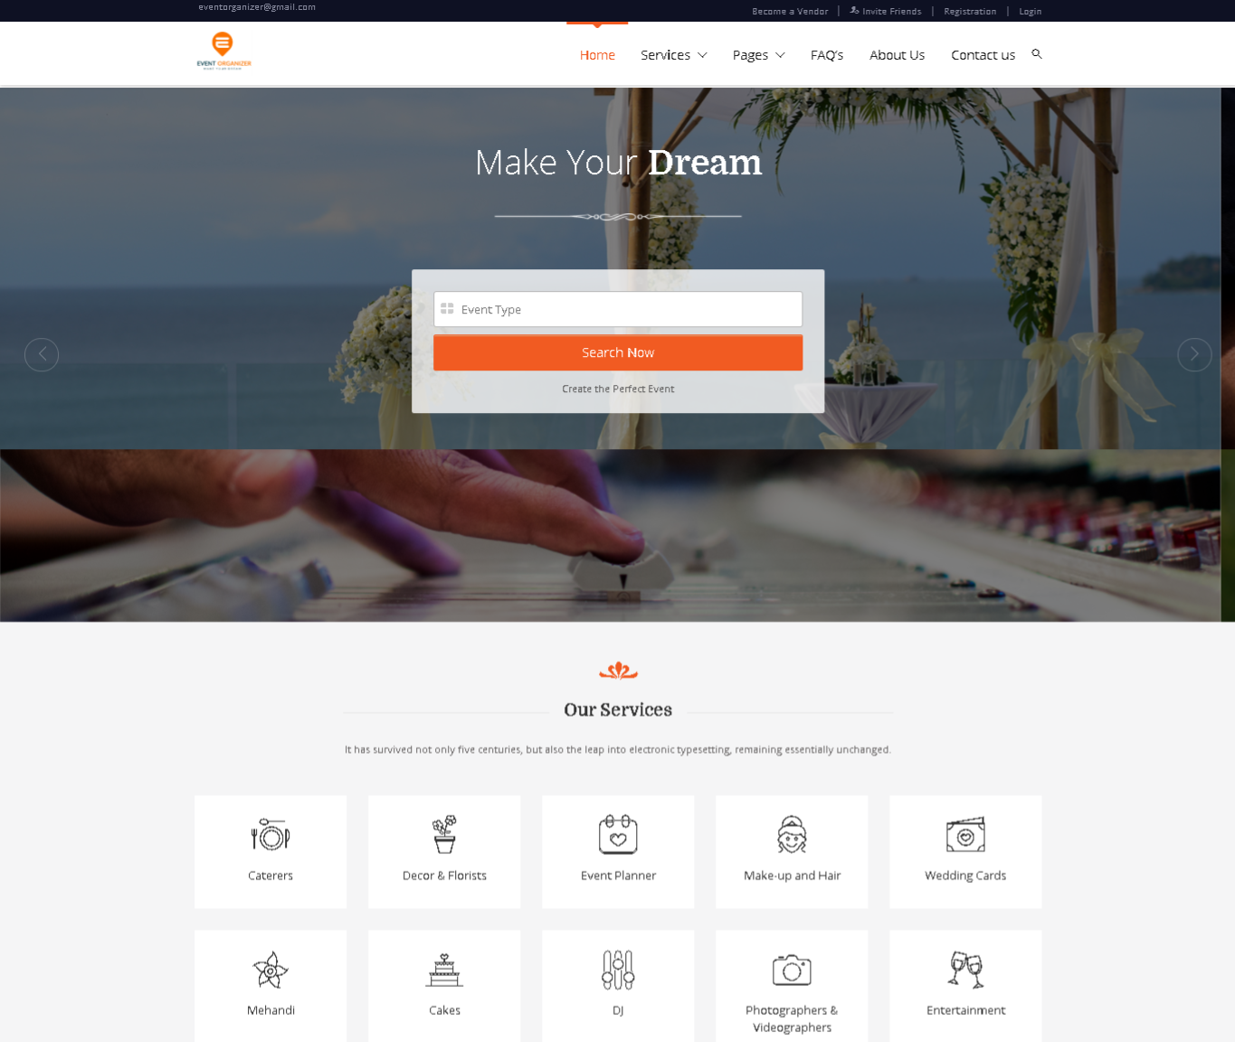

**Home Page – Main focus here is for users to search package and find event**

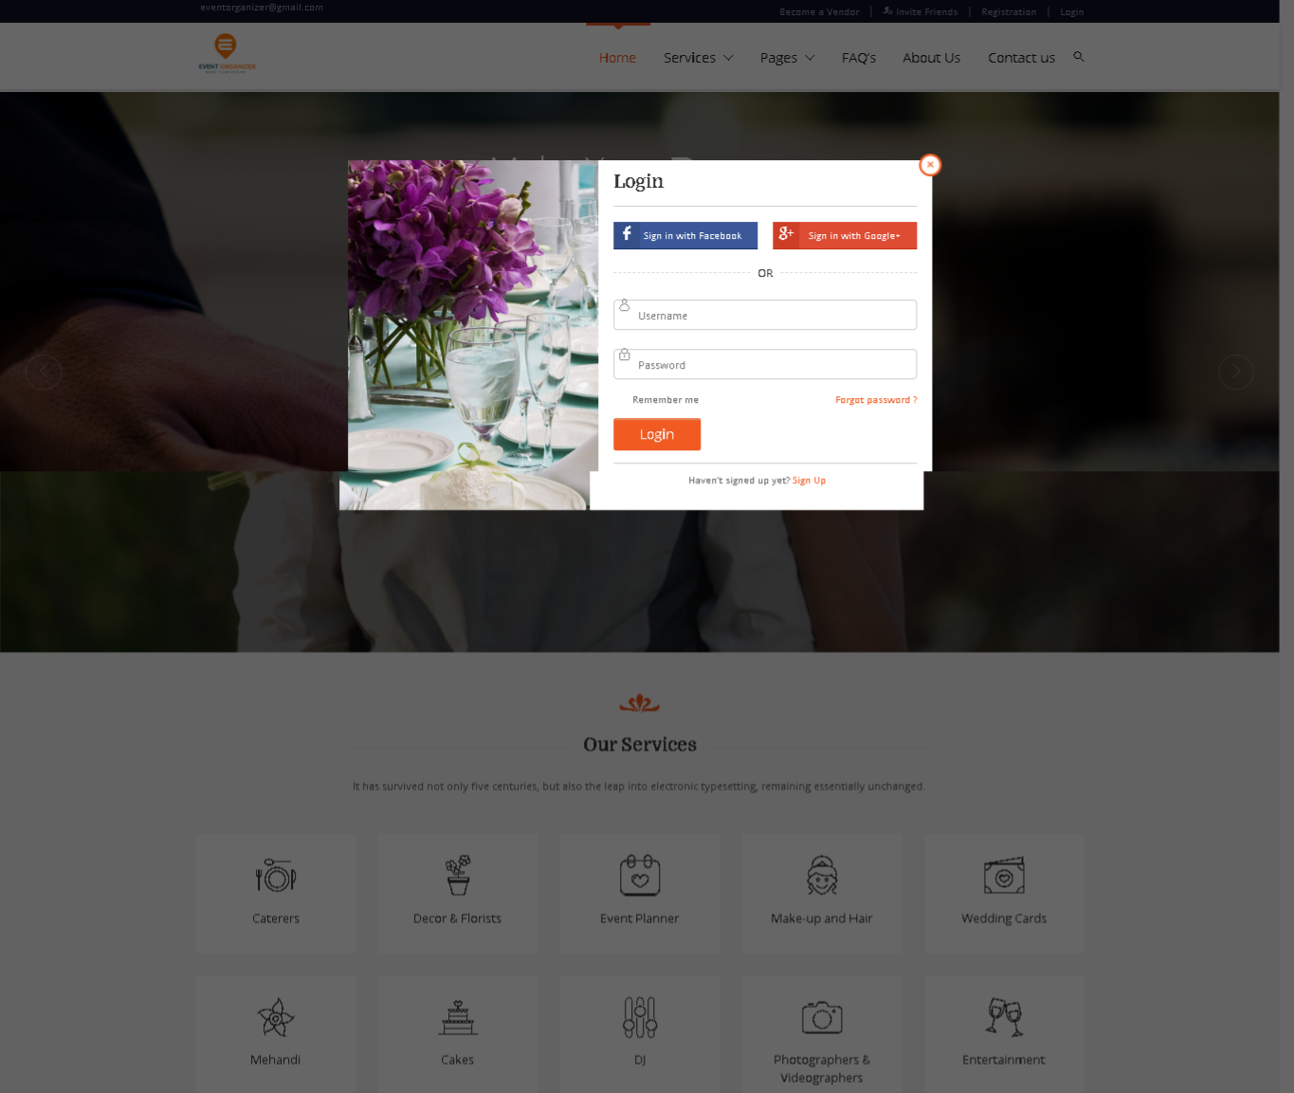

**Login – Users can login using their credentials**

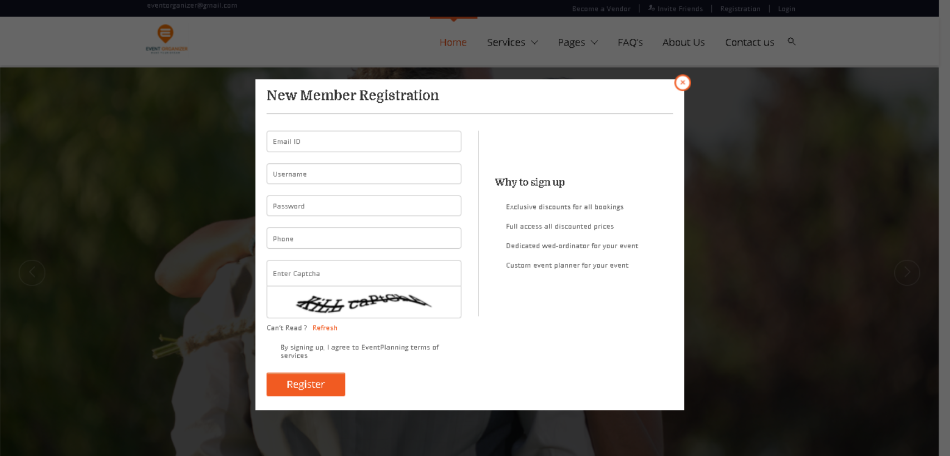

**Sign Up**

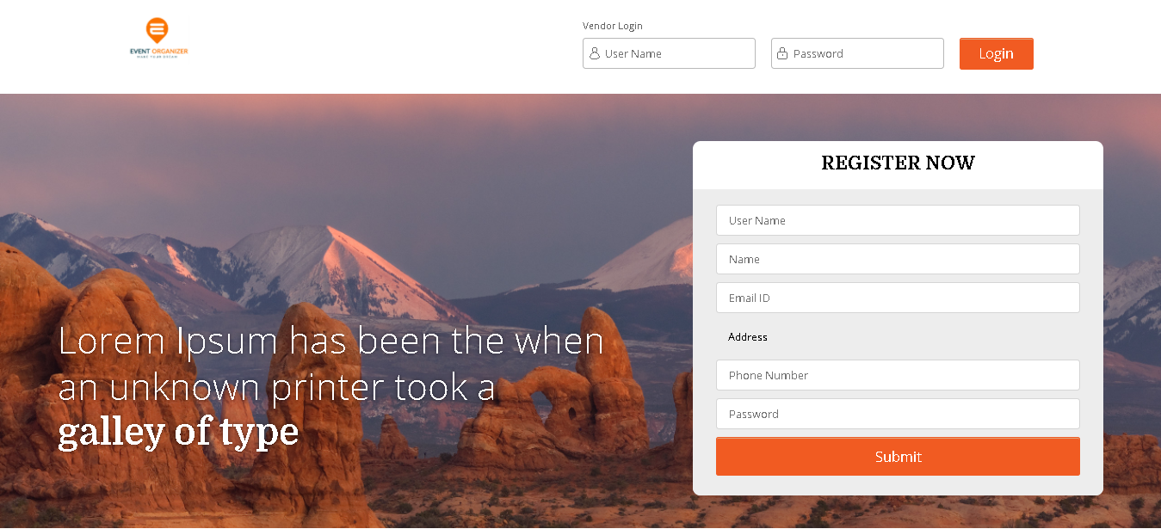

**Vendor login and Sign up**

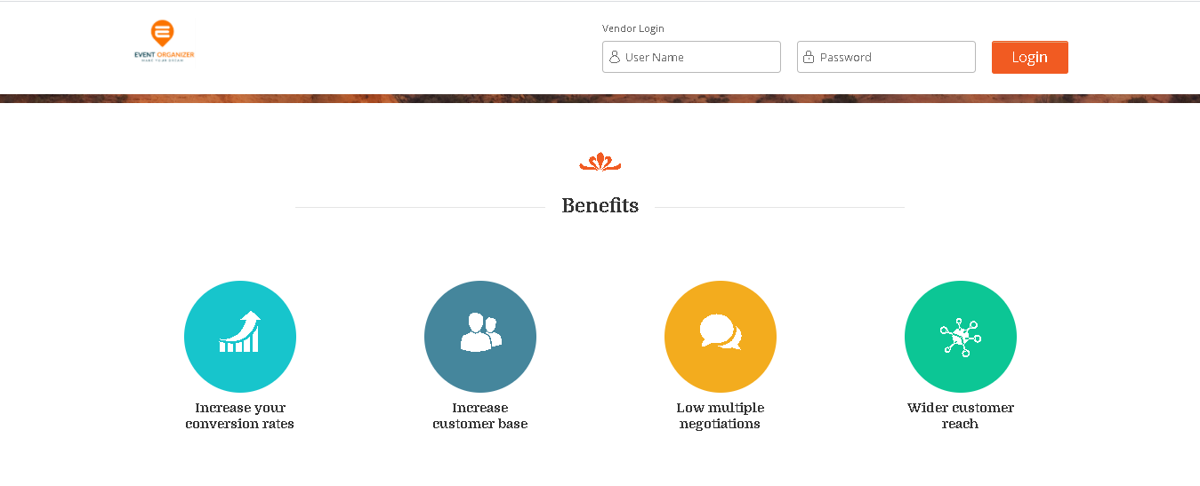**Vendor Benefits**

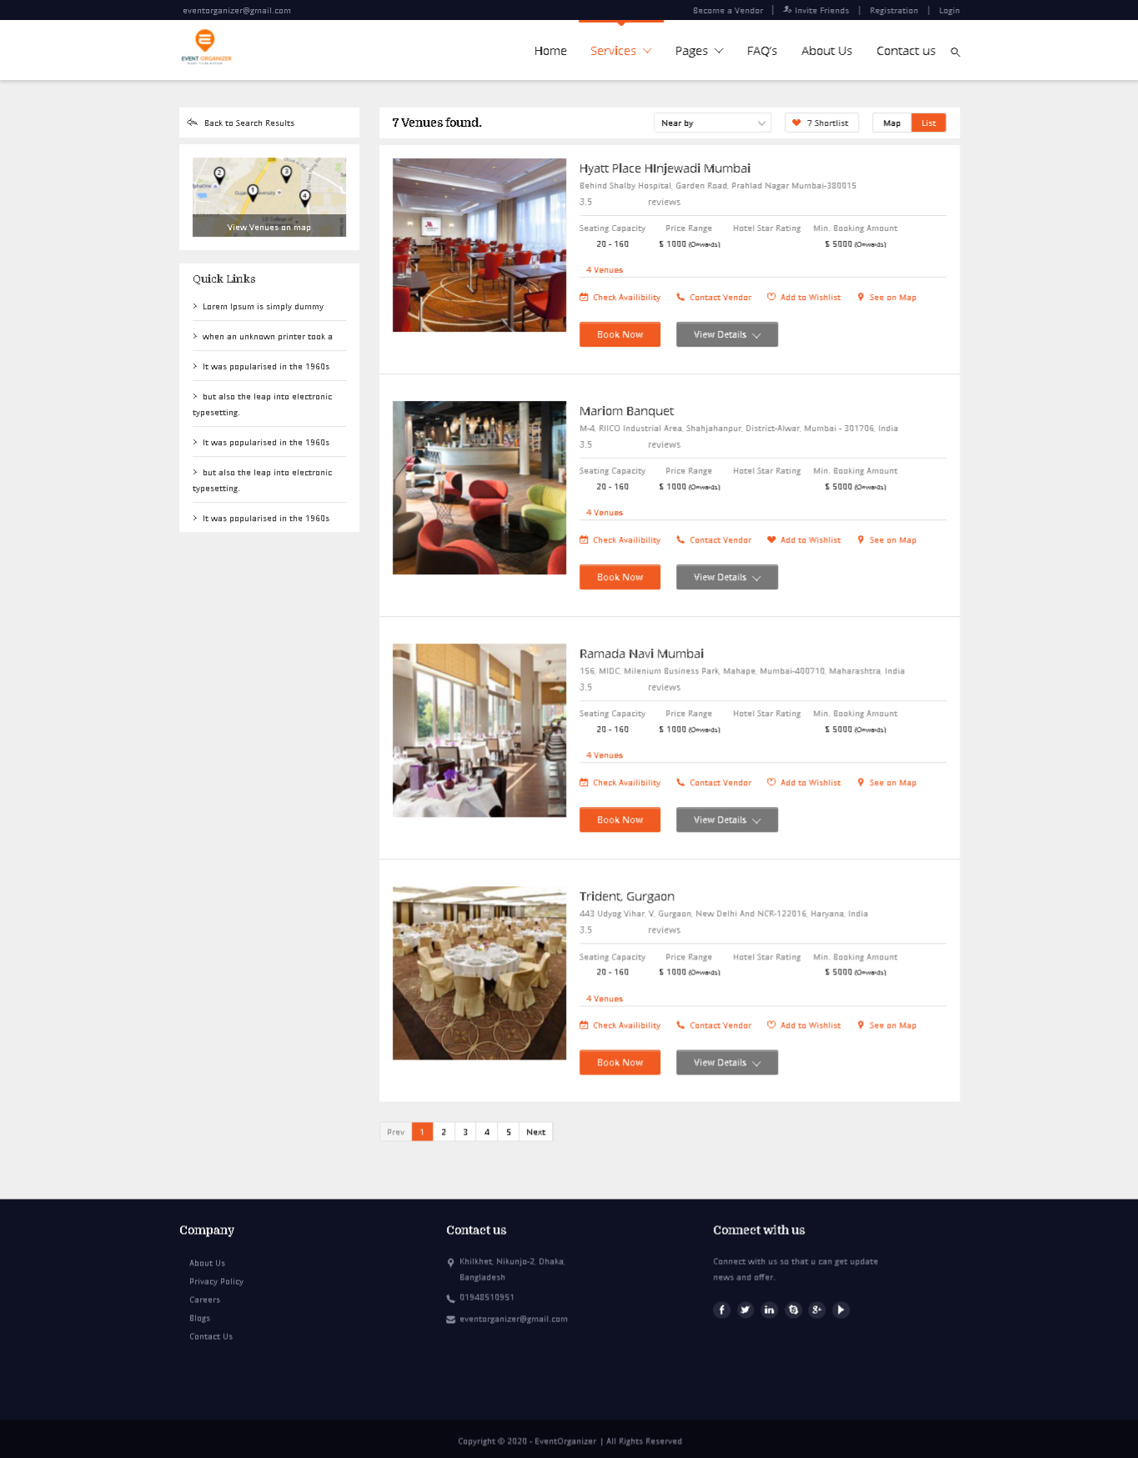

**Customer search for events and book event**



**Services**

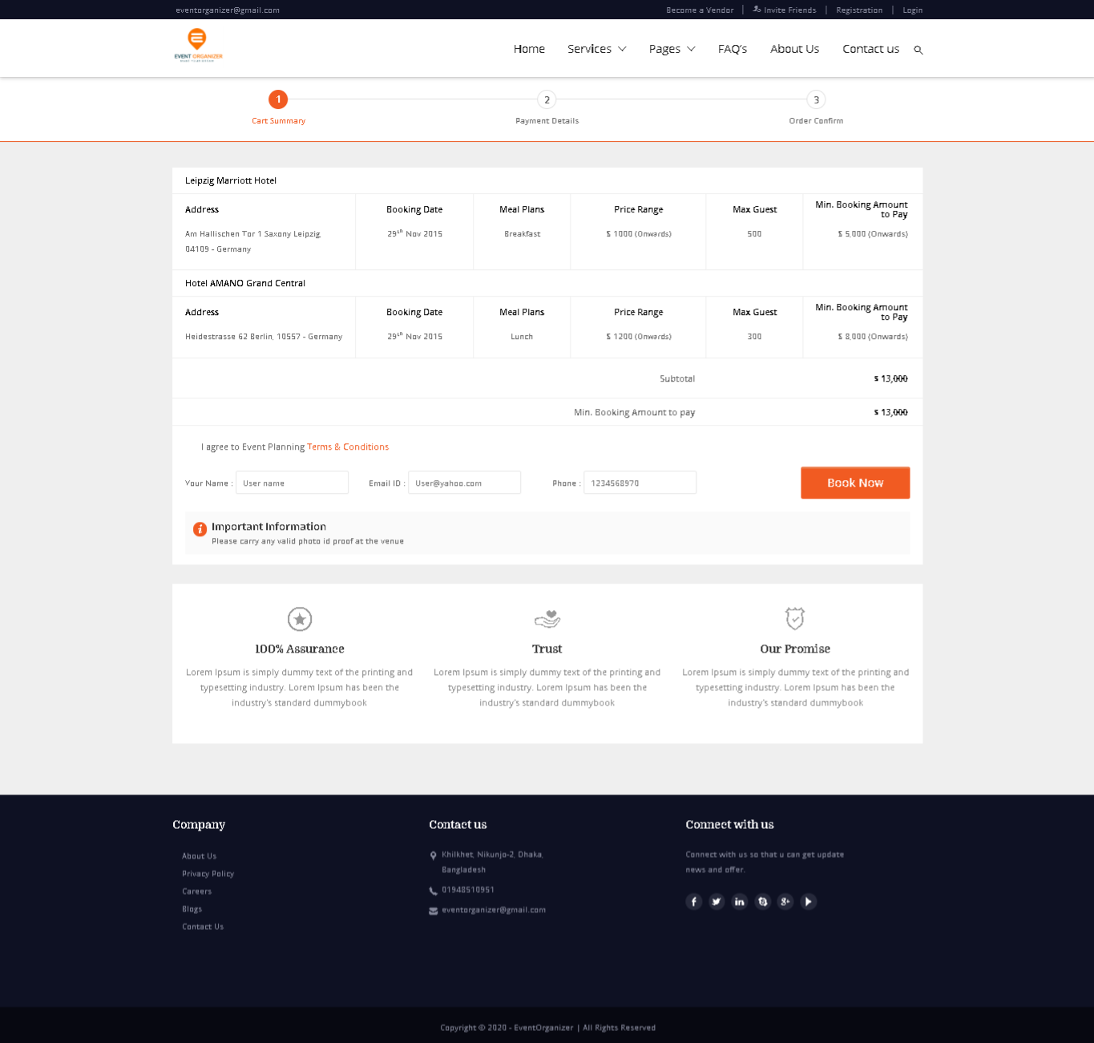

**Booking for event**

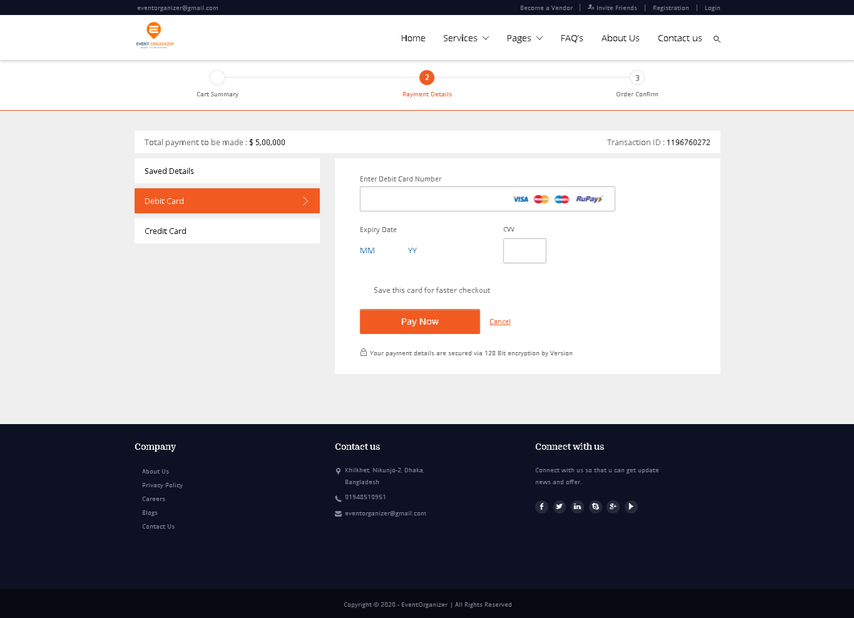

**Payment Details**

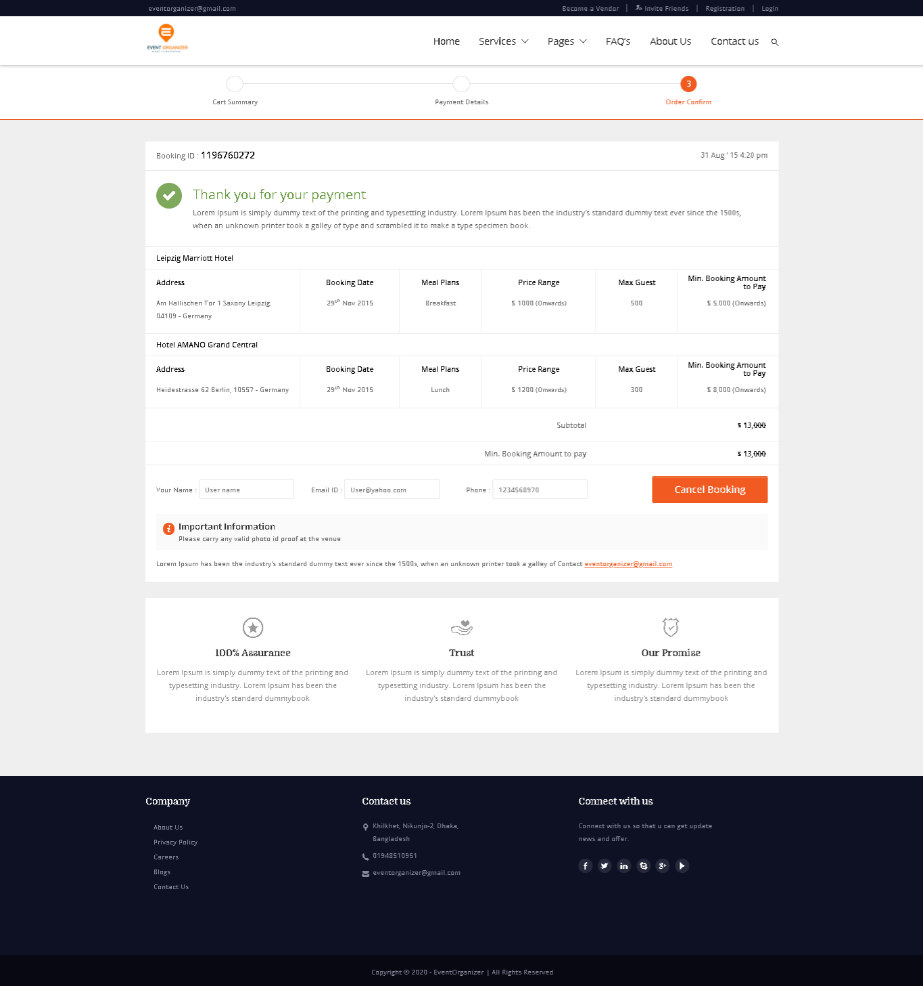

**Conform Order**

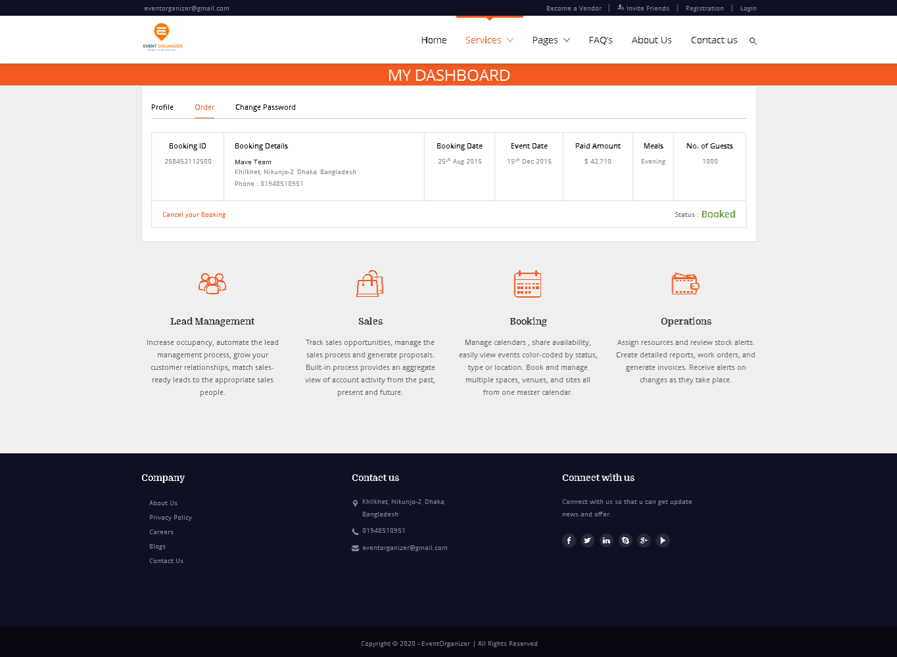**Order Details**

# CHAPTER-4: SOFTWARE PROJECT MANAGEMENT PLAN

## 4.1 Document History and Distribution

The development **Online Event Management System** is a knowledge based system where user can get all kinds of information of event packages and event demo. Also users can enjoy discount based upon new system user invitation. Users can benefit from this service by saving valuable time.

### 4.1.1 Test Plan

Case-1:

|  |  |  |  |  |
| --- | --- | --- | --- | --- |
| Project Name: Event management | | Test Designed by: Shanjida Hride | | |
| Test Case ID: FR_1 | | Test Designed date:15/8/2020 | | |
| Test Priority (Low, Medium, High): Medium | | Test Executed by: Sanzida Mannan | | |
| Module Name: System access | | Test Execution date: 02/09/2020 | | |
| Test Title: The system shall accessible via the internet. | |  | | |
| Description: Test the system which is accessed via the internet. | |  | | |
| Precondition: Need an internet connection.  Dependencies: can’t access via offline. | | | | |
| Test Steps | Test Data | Expected Results | Actual Results | 7Status (Pass/Fail) |
| 1. At first connect with the internet.  2. Access the system from a browser. | System address/IP address. | User can see the home page. | As expected | Pass. |
| Post Condition: User can see the system home page. | | | | |

Case-2:

|  |  |  |  |  |
| --- | --- | --- | --- | --- |
| Project Name: Event management | | Test Designed by: Shanjida Hride | | |
| Test Case ID: FR_2 | | Test Designed date: 15/8/2020 | | |
| Test Priority (Low, Medium, High): High | | Test Executed by: Sanzida Mannan | | |
| Module Name: Login and Registration | | Test Execution date: 02/09/2020 | | |
| Test Title: Login and registration validation. | |  | | |
| Description: Users can log in to the system if the user is valid. Otherwise, the user needs to do the registration. | |  | | |
| Precondition: The user needs a valid username and password.  Dependencies: The information of the user/vendor is right or wrong when they register in the system. | | | | |
| Test Steps | Test Data | Expected Results | Actual Results | 7Status (Pass/Fail) |
| 1) Connect to the internet and browse the website.  2) Click Sign in and fulfill all box. | Id : hride  Pass: 1234 | Login Successfully | Logged in | Pass |
| Post Condition: User can login successfully | | | | |

Case-3:

|  |  |  |  |  |
| --- | --- | --- | --- | --- |
| Project Name: Event Management | | Test Designed by: Shanjida Hride | | |
| Test Case ID: FR_3 | | Test Designed date: 26/8/2020 | | |
| Test Priority (Low, Medium, High): Medium | | Test Executed by: Rafiul Bondhon | | |
| Module Name: Searching | | Test Execution date: 4/9/2020 | | |
| Test Title: Search Event Type Results | |  | | |
| Description: User Can search different type of event and they will see the results of searching | |  | | |
| Precondition: User Need Valid Internet Connections to search login not mandatory  Dependencies: | | | | |
| Test Steps | Test Data | Expected Results | Actual Results | 7Status (Pass/Fail) |
| 1) Connect to the internet and browse a website  2) Search for different type of event | Searched for Rag Day event | Different type rag day event price with details | 3 types rag day event found with price | Pass |
| Post Condition:Users can see different types of event. | | | | |

Case-4:

|  |  |  |  |  |
| --- | --- | --- | --- | --- |
| Project Name: Event Management | | Test Designed by: Shanjida Hride | | |
| Test Case ID: FR_4 | | Test Designed date: 26/8/2020 | | |
| Test Priority (Low, Medium, High): High | | Test Executed by: Rafiul Bondhon | | |
| Module Name: Customer | | Test Execution date: 4/9/2020 | | |
| Test Title: Customer Can Contact Manager | |  | | |
| Description: From website contact us page user can fill up a form and that will be sent to Manager | |  | | |
| Precondition: Customer need a valid email address or Phone Number  Dependencies: Need internet connection | | | | |
| Test Steps | Test Data | Expected Results | Actual Results | 7Status (Pass/Fail) |
| 1) Browse website go to contact us page  2) Fill up the form and send | Name: hride  Subject: Rag Day Event  Email: [shanjidahride1997@gmail.com](mailto:rhshuvo97@gmail.com)  Message: We want to arrange Rag Day for us | Message sent to Manager | As Expected Message received by the manager | pass |
| Post Condition: Successfully send the form. | | | | |

Case-5:

|  |  |  |  |  |
| --- | --- | --- | --- | --- |
| Project Name: Event Management | | Test Designed by: Shanjida Hride | | |
| Test Case ID: FR_5 | | Test Designed date: 26/8/2020 | | |
| Test Priority (Low, Medium, High): High | | Test Executed by: Rafiul Bondhon | | |
| Module Name: Customer | | Test Execution date: 4/9/2020 | | |
| Test Title: Select Several event packages, and booking it. | |  | | |
| Description: Several event packages  that can be booked by the customer. | |  | | |
| Precondition: The user has to go to the Package page and choose packages.  Dependencies: Can’t Booking without login/registration. | | | | |
| Test Steps | Test Data | Expected Results | Actual Results | 7Status (Pass/Fail) |
| 1.go to the package page.  2. Choose packages.  3.go to the booking page.  4.booking user packages. | 1.select some wedding Package.  2.Click Booking. | 1. Booked packages. | As Expected Successfully booked packages. | Pass |
| Post Condition: User can see his/her booking package. | | | | |

Case-6:

|  |  |  |  |  |
| --- | --- | --- | --- | --- |
| Project Name: Event Management | | Test Designed by: Sanzida Mannan | | |
| Test Case ID: FR_8 | | Test Designed date: 27/8/2020 | | |
| Test Priority (Low, Medium, High): Medium | | Test Executed by: Shanjida Hride | | |
| Module Name: Review | | Test Execution date:5/9/2020 | | |
| Test Title: Review Check | |  | | |
| Description: Customers can see the review of a merchant and registered customers can give review | |  | | |
| Precondition: Must have a review section and the customer have to be logged in.  Dependencies: Unregister customers can’t give a review but see it. | | | | |
| Test Steps | Test Data | Expected Results | Actual Results | 7Status (Pass/Fail) |
| 1. After completing an event, go to the review section. And give a review.  2. After giving a review, it will convert with other reviews. | Input review within 1 to 5. | It will be Show in the package cart. | As Expected.  Show the review. | Pass |
| Post Condition: All customers can see the review. | | | | |

Case-7:

|  |  |  |  |  |
| --- | --- | --- | --- | --- |
| Project Name: Event Management | | Test Designed by: Sanzida Mannan | | |
| Test Case ID: FR_10 | | Test Designed date: 27/8/2020 | | |
| Test Priority (Low, Medium, High):  medium | | Test Executed by: Shanjida Hride | | |
| Module Name: Registered Customer | | Test Execution date: 5/9/2020 | | |
| Test Title: test notification box. | |  | | |
| Description: Only registered customers get notification about new updates and bookings. | |  | | |
| Precondition: Have to go to the notification box.  Dependencies: Unregistered customers do not get notification about new updates and bookings. | | | | |
| Test Steps | Test Data | Expected Results | Actual Results | 7Status (Pass/Fail) |
| 1.go to the notification box.  2. See notification about booking and new updates. | 1.Chack booking notification box for info of your booking package. | Show the specific notification | As Expected.  Show correct notifications. | pass |
| Post Condition: When you click a notification of a booking package, it shows the correct package details. | | | | |

Case-8:

|  |  |  |  |  |
| --- | --- | --- | --- | --- |
| Project Name: Event Management | | Test Designed by: Shanjida Hride | | |
| Test Case ID: FR_12 | | Test Designed date: 27/8/2020 | | |
| Test Priority (Low, Medium, High): High | | Test Executed by: Rafiul Bondhon | | |
| Module Name: Admin | | Test Execution date: 5/9/2020 | | |
| Test Title:test admin panel. | |  | | |
| Description: Admin can see/change the records of purchase confirmed, total customers, pending orders, vendors, payment transactions. | |  | | |
| Precondition: Admin must be logged into the system.  Dependencies: Without an admin account, other users cannot do this. | | | | |
| Test Steps | Test Data | Expected Results | Actual Results | 7Status (Pass/Fail) |
| 1.Login the system.  2. See the customer list/vendor list/order list.  3.Change/delete packages/vendor/customer. | 1.Username: admin  2.pass:1234  3. Delete wedding package-1. | Delete this package completely. | As expected.  Successfully deleted. | Pass |
| Post Condition: Vendor gets a notification when an admin deletes/changes a package. | | | | |

Case-9:

|  |  |  |  |  |
| --- | --- | --- | --- | --- |
| Project Name: Event Management | | Test Designed by: Shanjida Hride | | |
| Test Case ID: FR_14 | | Test Designed date: 28/8/2020 | | |
| Test Priority (Low, Medium, High): Low | | Test Executed by: Sanzida Mannan | | |
| Module Name: Admin | | Test Execution date:6/9/2020 | | |
| Test Title: test all types of order info. | |  | | |
| Description: Tracking the order system done by admin. | |  | | |
| Precondition: Must be logged in as an admin and customer have booked packages already.  Dependencies:If no customer booked a package,order list cannot check. | | | | |
| Test Steps | Test Data | Expected Results | Actual Results | 7Status (Pass/Fail) |
| 1.Order box shows previous and current booked.  2.Can delete order. | 1.delete 10 orders. | Show order list. | As expected.  Successfully order list work | Pass |
| Post Condition: Customer and vendor get notification. | | | | |

Case-10:

|  |  |  |  |  |
| --- | --- | --- | --- | --- |
| Project Name: Event Management | | Test Designed by: Shanjida Hride | | |
| Test Case ID: FR_15 | | Test Designed date: 28/8/2020 | | |
| Test Priority (Low, Medium, High): | | Test Executed by: Rafiul Bondhon | | |
| Module Name: Admin | | Test Execution date: 6/9/2020 | | |
| Test Title:Approval test | |  | | |
| Description:Admin can approve vendor registration. | |  | | |
| Precondition: Logged in as an admin.  Dependencies:Show it when vendor will registration in the system. | | | | |
| Test Steps | Test Data | Expected Results | Actual Results | 7Status (Pass/Fail) |
| 1.Approve a vendor account.  2.Delete a vendor account. | 1.Click approve, vendor will be registered.  2. Click delete, that account status will be no. | Admin can approve or delete a vendor account | As expected.  Account approve/delete successfully. | Pass |
| Post Condition: Database will be change for this account. | | | | |

Case-11:

|  |  |  |  |  |
| --- | --- | --- | --- | --- |
| Project Name: Event Management | | Test Designed by: Shanjida Hride | | |
| Test Case ID: FR_16 | | Test Designed date: 28/8/2020 | | |
| Test Priority (Low, Medium, High): High | | Test Executed by: Rafiul Bondhon | | |
| Module Name: User Info. | | Test Execution date: 6/9/2020 | | |
| Test Title:Check user password | |  | | |
| Description:For security purposes, a user’s password will be encrypted by the system. | |  | | |
| Precondition: User must be registered before.  Dependencies:Somehow unauthorized person know the password, he/she can get access. | | | | |
| Test Steps | Test Data | Expected Results | Actual Results | 7Status (Pass/Fail) |
| 1.Give a password which is encrypted in database.  2.If it is valid,user can access the account.  3.if password is not valid, It shows invalid password. | 1.username: admin  2.actual pass: 1234  3.Enter the pass: 123  4.Invalid password. | Show that invalid password. | As expected.  Show that. | pass |
| Post Condition:User try it again. | | | | |

Case-12:

|  |  |  |  |  |
| --- | --- | --- | --- | --- |
| Project Name: Event Management | | Test Designed by: Rafiul Bondhon | | |
| Test Case ID: FR_17 | | Test Designed date: 29/8/2020 | | |
| Test Priority (Low, Medium, High): High | | Test Executed by: Shanjida Hride | | |
| Module Name: Payment | | Test Execution date: 7/9/2020 | | |
| Test Title: Payment method check | |  | | |
| Description: Customer Can pay for their purchase order using bkash/bank transfer/ Later Payment | |  | | |
| Precondition: Need To Purchase a Package  Dependencies: Need to have valid payment account | | | | |
| Test Steps | Test Data | Expected Results | Actual Results | 7Status (Pass/Fail) |
| 1) Login system  2) Choose a Plan  3) Confirm Order  4) Make Payment | User Info: hride  Pass: 1234  Purchase package standard plan  Payment using bkash | Payment Successful | Paid By Bkash | Pass |
| Post Condition: Try using other payment methods | | | | |

Case-13:

|  |  |  |  |  |
| --- | --- | --- | --- | --- |
| Project Name: Event Management | | Test Designed by: Shanjida Hride | | |
| Test Case ID: FR_18 | | Test Designed date: 29/8/2020 | | |
| Test Priority (Low, Medium, High): Low | | Test Executed by: Rafiul Bondhon | | |
| Module Name: Suggestion | | Test Execution date: 7/9/2020 | | |
| Test Title:Similar Package Suggestion | |  | | |
| Description: When user see a package that time they will also get similar package suggestion. | |  | | |
| Precondition: User need to open a product details.  Dependencies:similar types package exist or not | | | | |
| Test Steps | Test Data | Expected Results | Actual Results | 7Status (Pass/Fail) |
| 1.browse website  2.go to a package details  3.see similar product | Marriage event package check | Different types marriage package show as suggestion | As expected three other package show as suggestion | Pass |
| Post Condition: Save user package view result | | | | |

Case-14:

|  |  |  |  |  |
| --- | --- | --- | --- | --- |
| Project Name: Event Management | | Test Designed by: Rafiul Bondhon | | |
| Test Case ID: FR_19 | | Test Designed date: 29/8/2020 | | |
| Test Priority (Low, Medium, High): High | | Test Executed by: Shanjida Hride | | |
| Module Name: Booking | | Test Execution date: 7/9/2020 | | |
| Test Title: Request For Booking Cancel | |  | | |
| Description: Customer can request for Booking cancel if time available than it can be cancelled | |  | | |
| Precondition: Customer Need to Book First  Dependencies: For successful booking need payment | | | | |
| Test Steps | Test Data | Expected Results | Actual Results | 7Status (Pass/Fail) |
| 1. Login  2. Book a plan  3. Try to cancel | Booking for rag day  Cancel Request with proper reason | Order Cancel | Order Not Cancelled | Fail |
| Post Condition: Try again for cancel | | | | |

## 

## 

### 4.1.2 Revision History

|  |  |  |  |
| --- | --- | --- | --- |
| **Revision #** | **Revision Date** | **Description of Change** | **Author** |
| 01 | September 20th ,  2020 | Primary Phage | Shanjida Hride |
| 02 | September 24th ,  2020 | Yes | Shanjida Hride |

These versions will show up there and also on its service work good.

**4.1.3 Distribution**

|  |  |  |
| --- | --- | --- |
| **Recipient Name** | **Recipient Organization** | **Distribution Method** |
| Abhijit Bhowmik | AIUB | Hard Copy, Soft Copy |
| Abhijit Bhowmik | AIUB | Hard Copy, Soft Copy |

Soft copy and Hard copy Distributed copy mention on the table.

## 4.2 Overview

### 4.2.1 Purpose, Objectives and Project Scope

The main objective of this document is to illustrate the requirements of the Event Management System project. The document gives detail description of both functional and non-functional requirements for this system [1]. The document is developed after a number of studying the requirement specifications paper of the given Project. The final product of the team will be meeting the requirements of this document.

### 4.2.2 Project Scope

* To development **Online Event Management System** where Users will feel easy to get information of event packages and event demo, choose packages.
* This system makes the administrative work easy.
* Multiple opportunities in one system like choose event packages and see demo.

### 4.2.3 Assumptions and Constraints

The assumptions during the projects are-

* The development team has not quite enough experience as a whole to complete the project.
* Additional resources (people or money) are not available for the project.

## 4.3 Project Deliverables

### 4.3.1 The list of project deliverables is:

1. Statement of Work (SOW)

2. Software Requirements Specification (SRS)

3. Software Project Management plan (SPMP)

4. Software Design Plan (SDP)

### 4.3.2 Schedule and Budget Summary

|  |  |
| --- | --- |
| **SCHEDULE** | |
| **MILESTONE OR MAJOR PROJECT DELIVERABLE** | **PLANNED COMPLETION DATE(DAY)** |
| SOW | July 5th , 2020 |
| SRS | July 20th , 2020 |
| SPMP | August 30th , 2020 |
| SDP | August 19th , 2020 |
| Soft testing plan | August 27th , 2020 |
| Presentation & project progress | September 5th , 2020 |
| Technical documentation | With completed product |
| Software evaluation report | Along with final submission |

## 4.4 Evolution of the Software Project Management Plan

The preliminary drafts of the SPMP will be submitted to the project manager and after approval; copies of the same will be distributed to the members of the group on the date as referred to in section 1.1.4

### 4.4.1 Definitions

|  |  |
| --- | --- |
| **Terms** | **Description** |
| SOW | Statement of Work |
| SRS | Software Requirement Specification |
| SPMP | Software Project Management Plan |
| SDP | Software Design Plan |
| SQATP | Software Quality Assurance and Testing Plan |
| Impact | 1-catastrophic  2-critical  3-marginal  4-negligible |

## 4.5 Project Organization

Project organization depends on three major Structures

### 4.5.1 External Interfaces

The system user relationship will be responsible for formal interaction between the developer’s team and the customer contact. Necessary interaction will be done through anyone on the team, but all discussions with the user will be documented clearly for record. All user requests for services or configuration item changes will be in writing and approved by the project’s Configuration Control Board (CCB) [2], which consists of all team members.

### 4.5.2 Internal Structure

There are four developers for this project. All members have specified areas of responsibility and everybody contributes equally to the project. Because there are only four members on the team, each member holds more than one role.

The team members will change roles throughout the life of the project, and each member will continue to have more than one role.

### 4.5.3 Roles and Responsibilities

The software developers are responsible for all documentation to be developed and also for all work to be done.

## 4.6 Managerial Process Plans

### 4.6.1 Project Start-up Plan

This section describes the materials and resources required to start the project. Because most of this information was pre-defined for the team, this section will not describe the rationale for many of these choices.

### 4.6.2 Estimation Plan

As previously stated in that, the total development time is estimated to be 6 days and the total internal cost to be BDT. These figures were obtained by expert judgment by analogy, that is, by comparison with similar projects.

### 4.6.3 Staffing Plan

Each team member will be available for 8 hours per day as the project purpose. This time includes the team and supervisor meetings, document preparation and inspection, and tool development.

### 4.6.4 Resource Acquisition Plan

* All resources for the project will be available at the start of the project and will not change substantially over time. Below are the planned changes: The technical writer will change after completing a documentation
* The team member’s roles will change according to project needs

### 4.6.5 Project Staff Training Plan

No additional staff training is needed for this project**.**

## 4.7 Work Plan

Work Activities and Schedule Allocation

### 4.7.1 Budget Allocation

|  |  |  |
| --- | --- | --- |
| **Budget Allocation** | | |
|  | **HOURS** | **COSTS** |
| **Agency Labour** |  |  |
| **Contract Labour** | N/A | 0 BDT |
| **Non-Labour Costs** | N/A | 0 BDT |
| **TOTAL HOURS / IMPLEMENTATION COST** |  |  |

## 4.8 Control Plan

### 4.8.1 Requirements Control Plan

When changes are to be made in the requirements after the Software Requirement Specification has been released, the changes shall be brought to the attention of the developers and discussed. Any changes that are to be made will be with the prior approval of the supervisor and only if feasible and permissible within the constraints of the project and resources in terms of knowledge and skill of the developers required. Once the changes have been made to the Software Requirement Specification document, an updated version of the Software Requirement Specification will be released.

### 4.8.2 Schedule Control Plan

If the work scheduled in section 1.1.4 is gets behind, the developer will be ready to spend extra time on the project in between and after the schedules to make up for the lost time and deliver the final project on time.

### 4.8.3 Budget Control Plan

Average monthly income will be determined by totaling all earnings for the year and dividing by 12. Average monthly spending will be generated by tracking all expenditures. "The difference between "Budget" and "Current Spending" will be the savings. If expenditure exceeds the income than steps may be follow to cut back on expenditures, depending on the specific savings goals. Expenses are monitored by the project manager, and reported and accessed via the Weekly Status Report.

### 4.8.4 Quality Control Plan

Any major changes that affect the milestones or the budget will have to be approved by all and documented. All will be responsible for ensuring that the project will be completed on time and within budget. This will be accomplished through daily meetings of the team members with the supervisor. At each meeting, developer team will present the day’s progress and problems. Al will determine whether they are progressing as expected and whether they are following the specification document and the project management plan. Any major problems faced by the team members will immediately be reported to all.

### 4.8.5 Reporting Plan

The updated Software Project Management Plan will be circulated as mentioned in schedule of section 1.1.4. Each of preliminary versions of all the documents and updates and status reports will be sent and discussed with the advisor and upon approval the approved document will be circulated to the other members of the team. The report on the status of the project will be sent to the members of the team.

### 4.8.6 Metrics Collection Plan

As the system based on object oriented so the metrics focus on measurement that can be applied to the class and the design characteristics—localization, encapsulation, information hiding, inheritance, and object abstraction techniques—that make the class unique.

## 4.9 Risk Management plan

|  |  |  |  |  |
| --- | --- | --- | --- | --- |
| **Risks** | **Probability** | **Impact** | **Rating** | **RMMM** |
| Project Manager Availability | 50% | 3 | Medium | R-1 |
| Schedule slips | 70% | 1 | High | R-2 |
| System goes hour | 60% | 3 | Medium | R-3 |
| Project cancelled | 30% | 4 | Low | R-4 |
| False feature rich | 40% | 2 | Low | R-5 |
| Programmers doesn’t have  good experience | 50% | 3 | Medium | R-6 |
| Late delivery | 50% | 3 | Medium | R-7 |
| Customer Participation in  Beta Testing | 30% | 4 | Low | R-8 |

## 4.10 Closeout Plan

At the end of the project, the following actions will occur:

* The developers team will make a hard copy file of all documents, source code, plans, etc. generated by the team.
* The developer team will also copy of all material in electronic format on a CD-ROM.

## 4.11 Technical process plans

The Software Project Management Plan will specify the development process model, technical models, tools and techniques that will be used to develop the work products, project infrastructure and product acceptance plan.

## 4.12 Process Model

The XP (extreme Programming) agile process model will be follow during the project implementation.

## 4.13 Methods, Tools and Techniques

The project, E-Commerce, adapts the system on Personal Computer using HTML, PHP, JavaScript, Visual Studio and MySQL for database management system. Additional tools that will be used are: Adobe Dreamweaver, Adobe Photoshop AWS EC2 Instance etc.

## 4.14 Infrastructure Plan

The hardware resources are three Intel Core2Duo Personal Computers running Windows XP/Vista or UBUNTU operating system. The project using software resources are like Notepad ++, Visual Studio Code, Adobe Dreamweaver, Adobe Photoshop, Adobe Flash, XAMPP etc.

## 4.15 Product Acceptance Plan

Every milestone of the project will be accepted formally by the project manager by signing appropriate acceptance documentation. At the end of every phase the project manager will perform an acceptance test. This may result in additional requests for change and improvements. The project manager will test the final product/application for acceptance.

## 4.16 Supporting Process Plans

The Software Project Management Plan will include the plans for the supporting processes that are part of the software project. These plans include: configuration management plan, verification and validation, software documentation, quality assurance, reviews and audits, problem resolution and subcontractor management.

## 4.17 Configuration Management Plan

All the project deliverables are to be considered as configuration items. The configuration item as well as its file would be named after the document like SOW, SRS and followed by the version number. For example, all the preliminary versions that are submitted to the project manager for review would be named with the abbreviation followed by 0.1, 0.2. After the project manager approves the basic SPMP, this baseline document will be version 1.0 and is distributed to the project members. Informal updates with the project manager will be numbered with 1.1, 1.2, etc. and the next full distribution to the committee would be version 2.0, etc.

## 4.18 Verification and Validation Plan

The Software Project Management Plan for this project shall contain the verification and validation plan for the software project and it shall include tools, techniques and responsibilities for the verification and validation work activities. The verification and validation plan will be part of a separate document and will be maintained accordingly.

## 4.19 Documentation Plan

The IEEE standards would be followed for all documentation purposes. All the documents would be discussed and reviewed with project manager before their baseline versions are issued and distributed to the members of the committee on the due dates.

## 4.20 Quality Assurance Plan

The quality of our project will be maintained and checked by the project manager. He will assure that this project is maintaining the quality.

## 4.21 Reviews and Audits Plan

Review and Audits would be addressed as a part of the Software Quality Assurance and Verification & Validation Plan that would be developed following recommended departmental standards.

## 4.22 Problem Resolution Plan

All problems would be resolved informally the developer and the project manager. That is, there is no specific plan. But, The Software Project Management Plan will be updated accordingly should the need for such a plan arises.

## 4.23 Subcontractor Management Plans

The project does not have any plan for managing subcontractors that may contribute work products to the software project.

## 4.24 Process Improvement Plan

After the development, the project will be regularly checked by the project manager and he will suggest the developers if any kind of improvement is needed.

# REFERENCES:

1. http://www.cse.msu.edu/~cse870/IEEEXplore-SRS-template.pdf

2. https://dinus.ac.id/repository/docs/ajar/Sommerville-Software-Engineering-10ed.pdf

3.

[https://iansommerville.com/software-engineering-book/web/domain-requirements](https://iansommerville.com/software-engineering-book/web/domain-requirements 4)

4. <https://dhakaeventplanner.com/>

5. <https://bdwedding.com/vendor/wedding_planner/iiedatanEvents/>

6. [https: //wedding_planner/DecorandDivine/](https://bdwedding.com/vendor/wedding_planner/DecorandDivine/)

7. [https:// vendor/wedding_planner/dmirrorevents/](https://bdwedding.com/vendor/wedding_planner/dmirrorevents/)

8. https://bdshowbiz.com/bangladesh-bd-event-management/

9. [https:/ wedding_planner/royalweddingbd/](https://bdwedding.com/vendor/wedding_planner/royalweddingbd/)

10. [https:/ wedding_planner/LimpidEvent/](https://bdwedding.com/vendor/wedding_planner/LimpidEvent/)

11. <https://www.banglaeventmanagement.com/>

12. <https://www.facebook.com/BDEventManagement/>

13. <https://www.facebook.com/pandapandel2016/>

14. <https://bookboon.com/en/project-management-ebooks>

15. <https://en.wikipedia.org/wiki/Risk_management_plan>

16. <https://www.phe.gov/about/amcg/contracts/Documents/risk-management.pdf>

17. http://en.wikipedia.org/wiki/Software_project_management

18. **Software-Engineering-9th-Edition-by-Ian-Sommerville**